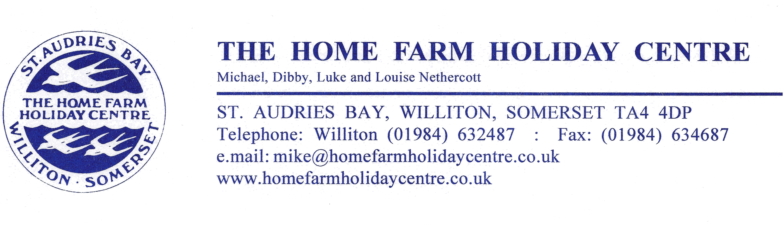
12 December 2023

FAO: Customer Care
Surf Bay Leisure
The Airfield
Winkleigh
Devon
EX19 8DW

As agreed, please see below reimbursement for replacing the broken window in one of our rental caravans due to the screw being too tight and causing a crack which extended.

Invoice for replacement window on Swift Bordeaux 041028H

Net £146.00
Vat £29.20

Total £175.20

Please make payment within 14 days to:
Home Farm Holiday Centre
Account number: 00103615
Sort Code: 30-19-57
Lloyds Bank Business

If you have any queries please do not hesitate to contact us on 01984 632487.

Best wishes

Laura

